Chapter 19, Solution 27.

Consider the circuit in Fig. (a).
0.1 V₂
10 
20 I₁
+
−
V₁
(a)
−
+
I₁
I₂
+
V₂ = 0
−
4 
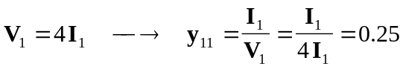

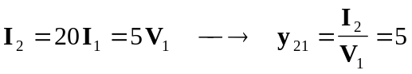

Consider the circuit in Fig. (b).
0.1 V₂
10 
20 I₁
+
−
(b)
−
+
I₁
I₂
4 
+
V₁ = 0
−
V₂

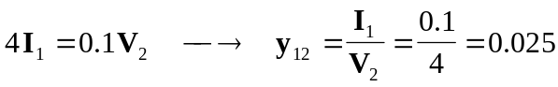

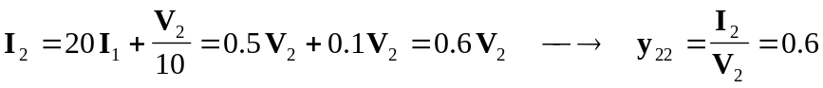

Thus,
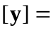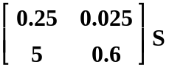

Alternatively, from the given circuit,
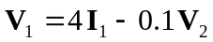
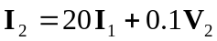

Comparing these with the equations for the h parameters show that
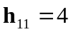, 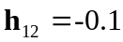, 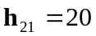, 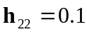

Using Table 18.1,
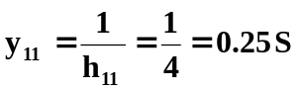, 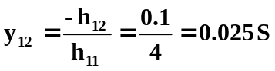
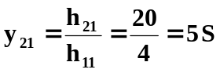, 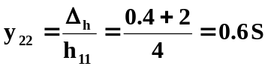
as above.

